附件一：
Professional Learning Communities of New Taipei City
Native English-Speaking Teachers
Professional Learning Communities (PLCs) are meetings for teachers to develop curriculum for summer and winter camps, which is required for New Taipei City Native English-Speaking Teachers (NESTs). NESTs have been grouped by area into teams of seven to eleven people to create 5 PLC groups. There will be three in-person PLC meetings and one online PLC meeting that will take place during this fall semester. All NESTs are required to attend all sessions to prepare for camp.

PLC Meeting Goals:

Meeting 1: In-Person (10/18/2023)
Meeting 1 will cover the operational details for the implementation of the camp, such as; locations, dates, times, camp compensation, lead teacher roles, co-teacher roles, camp schedule, camp themes, lesson creation assignments, lesson titles, e-Class PLC group chat communication, and NAS2 online file sharing system. By the conclusion of the meeting, each PLC group will submit a Camp Trajectory document for their camp to NAS2 (Due on Friday, October 20th, 2023.)

Meeting 2: Online Lesson Collaboration (11/01/2023)
Meeting 2 will be set up and conducted by the PLC group Lead Teacher. This online meeting is an opportunity for NESTs to collaborate with their fellow PLC group members on lesson creation, provide peer feedback or ideas for lesson(s) development and to discuss purchase list budget disbursement.

Task Assignments 1 (11/22/2023):
Following Meeting 1 and before Meeting 3, each NEST is required to complete their assigned lesson creation assignments on the Camp Trajectory document, as well as, a purchase list of materials required for each lesson. This is to be completed on the appropriate template for each lesson provided on NAS2. All documents are required to be uploaded to the appropriate folder on NAS2 by Wednesday, November 22nd, 2023.

Meeting 3: In-Person (12/6/2023)

Meeting 3 will be conducted at Xiude Elementary School. NESTs will meet with the host school to which each PLC group has been assigned. At the meeting, NESTs will present their Camp Trajectory document, a brief overview of the lessons, discuss the purchase list, create a line of communication, and discuss facility needs. Each PLC group Lead Teacher will also need to upload to NAS 2 an updated version of the camp Purchase List (Due on Friday, December 8th, 2023. ).

Task Assignments 2 (12/27/2023):
Following Meeting 3, and before Meeting 4, each NEST is required to upload the final draft of content materials (PPTs and Handouts) for the individual lesson creation assignments on their individual PLC group Camp Trajectory document. All documents are required to be uploaded to the appropriate folder on NAS 2 by Wednesday, December 27th, 2023.

Meeting 4: In-Person (1/10/2024)
Meeting 4 will be conducted at the host school to which each PLC group has been assigned to. PLC group members will confirm the camp schedule with the host school, confirm the co-teacher roles, cover the student’s arrival and departure plan, tour the facility to view the locations and requested room equipment of the classrooms, auditorium, and indoor/outdoor spaces to be used during camp, and to verify that all purchase list items are present and allocated to the proper NEST.

PLC Groups and Meeting Time
Group | School | Time & Location
PLC1  (10 teachers) | 竹圍國小 - Zhuwei Elementary School  Mr. Marc Chih-Hao Hsu | Meeting 1:  October 18th Wed.  2:00～5:00 p.m.  Xiude Elementary School  Meeting 2:  November 1st Wed.  2:00～5:00 p.m.  Online, hosted by Lead Teachers  Meeting 3:  December 6th Wed.  2:00～5:00 p.m.  Xiude Elementary School  Meeting 4:  January 10th Wed.  2:00～5:00 p.m.  Winter Camp Host Schools
PLC1  (10 teachers) | 淡水國小 - Tamsui Elementary School  Mr. Gregory Edward Earle
PLC1  (10 teachers) | 五華國小 – Wuhua Elementary School  Ms. Sizakele Jama
PLC1  (10 teachers) | 鄧公國小 - Dengkong Elementary School  Mr. Kenneth Burks
PLC1  (10 teachers) | 鷺江國小 – Lujiang Elementary School  Ms. Julia Madonna Emmanuel
PLC1  (10 teachers) | 白雲國小 – Baiyun Elementary School  Mr. Jeffrey Robert Young
PLC1  (10 teachers) | 二重國小 –Erchong Elementary School  Mr. Steven Diez Blackwell
PLC1  (10 teachers) | 永福國小 –Yongfu Elementary School  Ms. Iriz Tejam
PLC1  (10 teachers) | 修德國小 – Xiude Elementary School  Mr. Robert Jacobson  Mr. James Wiley Dewberry
PLC2  (7 teachers) | 麗林國小 – Lilin Elementary School  Mr. Benjamin Eric Vandiver
PLC2  (7 teachers) | 頭湖國小 – Touhu Elementary School  Ms. Maria Nelavel Aseniero Balaobao
PLC2  (7 teachers) | 新林國小 – Xinlin Elementary School  Mr. Rooney Adam Michael
PLC2  (7 teachers) | 麗園國小 –Liyuan Elementary School  Ms. Amber Mc Kinnon
PLC2  (7 teachers) | 南勢國小 - Nanshi Elementary School  Mr. Darcy Lopez
PLC2  (7 teachers) | 明志國小 – Mingzhi Elementary School  Ms. Diana Kao
PLC2  (7 teachers) | 民安國小 – MinAn Elementary School  Mr. Davidson III Albarico Pillado
PLC3  (9 teachers) | 昌平國小 – Changping Elementary School Ms. Neliswa Hersly Matiwane | Meeting 1:  October 18th Wed.  2:00～5:00 p.m.  Xiude Elementary School  Meeting 2:  November 1st Wed.  2:00～5:00 p.m.  Online, hosted by Lead Teachers  Meeting 3:  December 6th Wed.  2:00～5:00 p.m.  Xiude Elementary School  Meeting 4:  January 10th Wed.  2:00～5:00 p.m.  Winter Camp Host Schools
PLC3  (9 teachers) | 中信國小 – Zhongxin Elementary School  Mr. Nelson Kent Sellars
PLC3  (9 teachers) | 思賢國小 – Sixian Elementary School  Ms. Rhondine Devon Panton
PLC3  (9 teachers) | 文聖國小 – Wensheng Elementary School, Ms. Sunny Wimleem Weng  Mr. John Jeffrey Linskey
PLC3  (9 teachers) | 江翠國小 –Jiangcui Elementary School  Mr. Charles Martin Kempf
PLC3  (9 teachers) | 廣福國小 – Guangfu Elementary School  Ms. Liana Shantell Conradie-Abrahams
PLC3  (9 teachers) | 新莊國小 –Xinzhuang Elementary School  Ms. Joanna Chris Vergara De Veyra
PLC3  (9 teachers) | 武林國小 –Wulin Elementary School  Ms. Tertia Mokwena
PLC4  (8 teachers) | 龍埔國小- Longpu Elementary School  Ms. Michelle Vatcher  Ms. Rorisang Millicent Rabalago  Ms. Angela Patrice Yap Lara  Ms. Hanna Mae Gales Dioleste
PLC4  (8 teachers) | 北大國小 – Beida Elementary School  Mr. Joshua Cratic
PLC4  (8 teachers) | 頂埔國小- Dingpu Elementary School  Mr. Michael David Parkes
PLC4  (8 teachers) | 安溪國小 –Anxi Elementary School  Ms. Siphindile Hyacinth Magwaza
PLC4  (8 teachers) | 鳳鳴國小 –Fengming Elementary School  Mr. Kevin Blair Grant
PLC5  (11 teachers) | 安坑國小 –Ankeng Elementary School  Ms. Vuyiswa Dube (Tracy)
PLC5  (11 teachers) | 大豐國小 –Dafeng Elementary School  Mr. Redawaan Hendricks
PLC5  (11 teachers) | 頂溪國小 –Tinghsi Elementary School  Mr. Tracy Charles Brashaw
PLC5  (11 teachers) | 北新國小 –Beixin Elementary School  Ms. Nocthula Lesego Nemalima
PLC5  (11 teachers) | 瑞芳國小 –Ruifang Elementary School  Ms. Daniella Canales Nuñez  Mr. Fidel Amante Ramos
PLC5  (11 teachers) | 新和國小 –Xinhe Elementary School  Ms. Christine LY
PLC5  (11 teachers) | 光復國小 – Kuangfu Elementary School  Mr. Sudesh Ramsammy  Ms. Charmie Lynne Gudarido Lin  Ms. Armitage Mao Chen  Mr. Henry Phan Lee

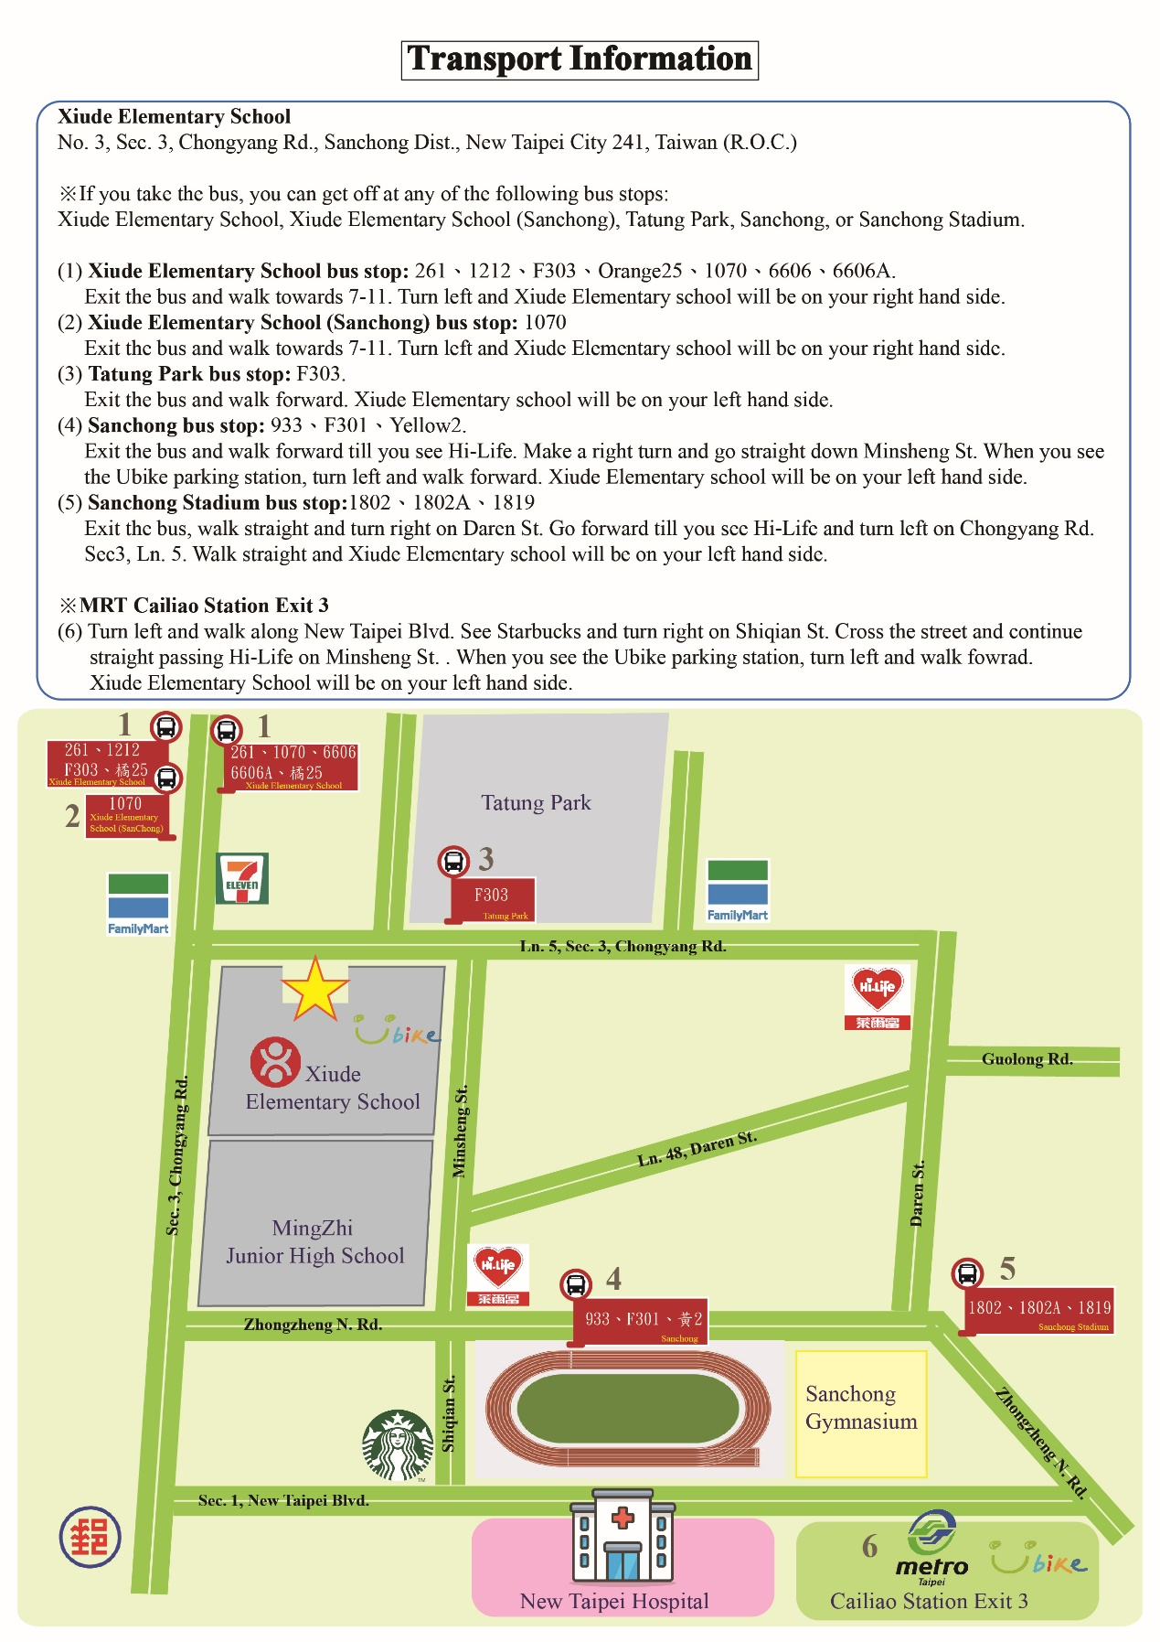
附件二：

